Maksat Mametjumayev

March 4, 2022

**Code Architecture and Tests of Programming App for Maksatly Carpet Dealers.**

I am developing a program is related to my future business and it is called ***Maksatly Carpet Tracking.***  This document shows a description of key user interactions with the program as well as a high-level sketch of the architecture of the program. Furthermore, I described some tests that can be applied to confirm the operation of the program

**About the program:** The program keeps tracking of Turkmen carpets of the Maksat store, The carpet dealers will access to edit the information regarding items such as adding the item, editing the description of carpet, editing sale status, putting an assigned price, and so on. However, managers and executive officers will access to view, for example, what carpet is assigned to which dealer, when it was sold, when it was posted to sale, and so on.

**Interactions:**

As this program is for mostly Maksatly Carpet dealers that means the user will mostly refer to carpet dealers. Following that, there are some sceneries for the user to interact with the program:

* On the entrance page, the program asks the user to type User’s Email, Password, and Employee Id.
* After providing the required information correctly, the Maksatly Carpet inventory table will appear.
* On the top of the table, the user will be able to see *a search button*. By clicking the search button they can type carpet’s name, posted date, sale’s status, price, size, and dealer’s name to find preferred carpet or filter them.
* On the bottom, they can see add button which will take a separate page. Clicking add button user again needs to provide their User’s Email, Password, and Employee Id.
* Clicking add button user needs to type their answer such as:
  + - Number/and posted date. The number of the carpet will be based on the posted date, for example, the newly posted carpets will take the last numbers.
    - Carpet’s name. The user can type the name of the Carpet.
    - Carpet’s size- The user can type the carpet’s size which is based on width (inch) x height (feet).
    - Price- The user can type the carpet’s price in USD.
    - Sale Status- The user can select sale status such as in stock, sold, or returned. For example, when the user chooses **Option 1-In stock.** It asks them to provide store names such as eBay, Amazon, or own Maksatly online store and so on **Option 2-Sold**. When the dealer chooses this option, it asks to put the date of sale and upload the receipt, **Option 3-Returned.** When a dealer chooses this option, it requires them to provide returned date and explain the reason for the return. The system accepts 0-60 days between sold date and returned date. In other words, the system will not allow the to dealer choose the returned option if the carpet is returned 60days after it was sold.
    - Dealer’s name- name automatically will be added based on their employee account
* On the bottom, the user again needs to provide their User’s Email, Password, and Employee Id.
* After providing the required information, the user can add them by clicking Add to The System button.

The layout of the program's graphical user interface is as it was shown in the attached sheet.

**Architecture:**  The program consists of three components- a data file, controller software to mane the program, and a graphical user interface. Likewise to Excel worksheets, the database requires only one table that has 6 columns where data can be stored in a simple text file. At start-up, the program asks for some information from the user such as employment account to display carpet inventory table. While the program runs, the user such as carpet dealer, can add, or edit modify items in the database. The program closes the database file and quits it by existing it. Accordingly, the controller software receives inputs and demands from the graphical user interface. Upon necessity. The controller software can access the database and update the graphical user interface. The architecture diagram is as it was shown in the attached sheet.

**Tests:**

The possible tests for the program:

* The user enters its employee account information. The table will be displayed.
* The user enters its employee account information incorrectly. The table will not be displayed.
* The user enters inexistent information on the table in the search section. The table will disappear.
* If Mangers try to add an item in Add section. Quite a program, restart. Because only dealers have access to add it.
* The user enters text where the number was asked to enter such as under the price column, height, and width column. Quite a program, restart.
* The user enters information properly for adding the item. The table will be refreshed.

***Graphical User Interface***

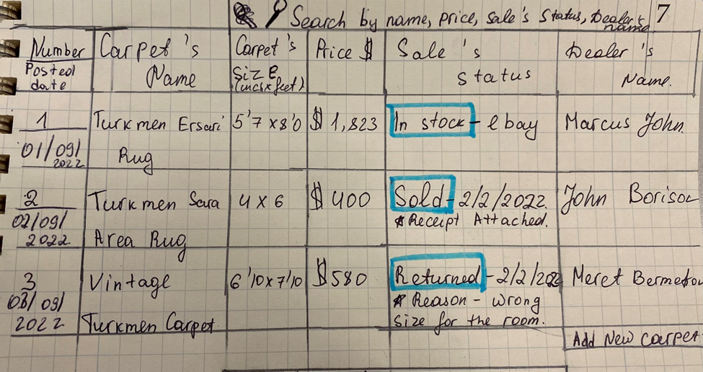

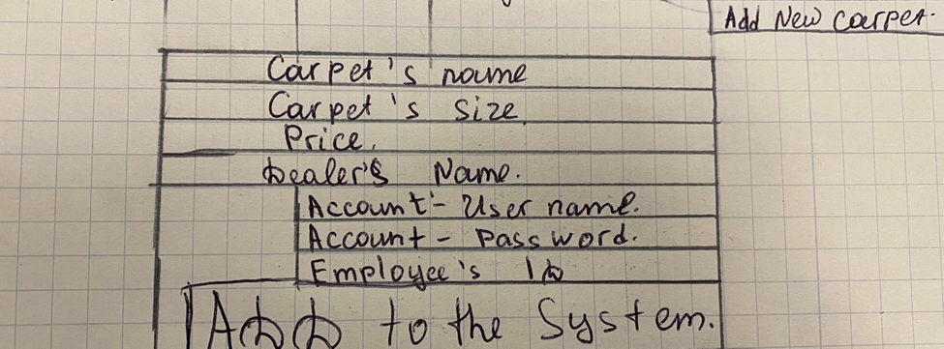

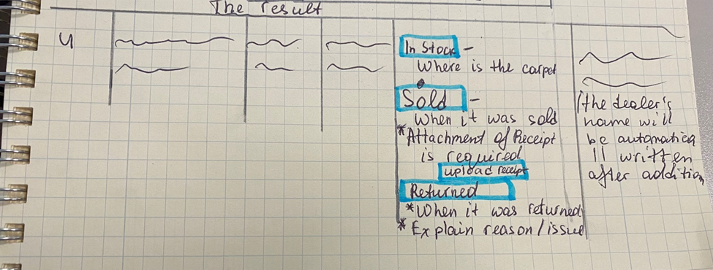

***Archetecture Design***

